Theme 6

Hall of Fame

Pupil Resource Sheet 4

Johnny Rogers

John Henry Rogers was born in Abergwynd in South Wales in October 1892. He later lived in Tondu, three miles north of Bridgend.

In 1906 Bridgend’s outstanding rugby union forward, Ben Gronow, was impressed by Johnny, during a midweek club match, even though Johnny was only 14 and very slightly built. Shortly afterwards, one of Bridgend’s wing three-quarters was unable to play and, spying Johnny in the crowd, Ben invited him to play.

Johnny played so well that he was made first reserve for the backs. When his chance came he formed a great partnership with Welsh international stand-off Clem Lewis, first for Bridgend, then for Cardiff when the pair moved in the 1911-12 season.

After 35 matches for Cardiff, Johnny ended his rugby union career, re-joining former Bridgend team mate Ben Gronow when Huddersfield paid £100 for him. On 1st March 1913 he made his Huddersfield debut, scoring three tries and a goal as Huddersfield beat Bramley 73-5.

Aged 20, Johnny soon impressed with his exceptional acceleration over the first ten yards, and a side-step/swerve that left defenders in his wake.

Johnny became first choice half back in 1913-14. Also occasionally used a goal kicker, he scored 20 tries and kicked 27 goals that season, picking up two trophies – the Yorkshire League and the Yorkshire Cup when Bradford Northern were beaten 19-3 in the final. Surprisingly, Huddersfield lost the Championship final 5-3 to Salford.

He also played the first of his three matches for the Wales northern union team that season, and toured Australia and New Zealand with the Lions in the summer of 1914, kicking two goals in a 12-7 defeat against Australia at Sydney.
Then came the season for which the Team of all Talents is remembered, 1914-15. War had been declared on Germany in August 1914, but the rugby and football seasons went ahead as the war was expected ‘to be over by Christmas’. No-one had any idea how long and dreadful the war would be. As casualties began to return from the front, Huddersfield’s northern union team helped to keep spirits up in the town.

Huddersfield retained the Yorkshire Cup, defeating Hull 31-0 in the final. The Yorkshire League followed. Leeds were beaten 35-2 in the Championship Final, and St Helens were thrashed 37-3 in the Challenge Cup Final, Johnny scoring a try in each game. Huddersfield had become the second team, after Hunslet in 1908, to win all four trophies in one season. Only Swinton, in 1928, have done since.

Huddersfield’s great team had an average age of 25 in 1915. When post-war rugby started in 1919 their best years were behind them, but they still had a little left, winning the first two post-war Yorkshire Cups, and the 1919-20 Yorkshire League. They added the 1920 Challenge Cup with a 21-10 win over Wigan in the final, and another four trophies looked likely. Unfortunately, when Huddersfield played Hull in the Championship Final five of their stars, including Johnny, were already sailing to Australia for that summer’s Great Britain tour. Hull took advantage, winning 3-2.

Johnny played in three Test Matches on the tour, kicking three goals in a 23-13 win over Australia at Sydney. His tour ended early when he broke his left leg in Auckland. He was unable to play again until the following January (1921). He played two further test matches in 1921 and his seventh and final match for Great Britain in 1922.
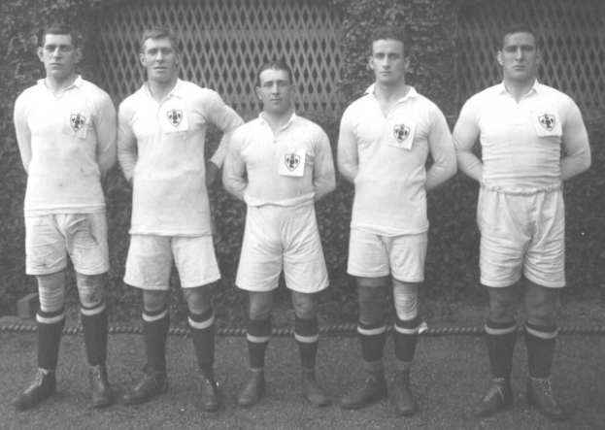
Huddersfield’s five Lions tourists, 1920:
Ben Gronow; Harold Wagstaff;
Johnny Rogers; Gwynne Thomas;
Douglas Clark

Although Huddersfield won the Yorkshire League in 1922 and reached the championship final again in 1923, losing 15-5 to Hull Kingston Rovers, the Team of all Talents was ageing and breaking up.

Johnny played his last game for Huddersfield in 1925. He ended his career with two seasons at Wakefield Trinity.

The Welsh wizard had come to regard Huddersfield as his home. After his playing career ended he was the licensee at the Plumber’s Arms in the town for many years. He retired from work in 1955 but continued to live at the Plumber’s Arms until his death on 26th July 1958, aged 65.

Johnny Rogers: Playing Record
Team | Matches | Tries | Goals | Points
Huddersfield | 262 | 106 | 47 | 412
Wakefield T | 57 | 7 | 11 | 43
Lions (Tests) | 7 | 0 | 6 | 12
Lions (Tour) | 12 | 4 | 3 | 18
Wales | 3 | 1 | 0 | 3
Other | 1 | 1 | 0 | 3
Totals | 342 | 119 | 67 | 491

